-->html-hypertext markup language
->it do the structure and formatting of the webpage.
->the difference between the normal text and after doing the html we can add a perfect structure to represent it and have a some format
-->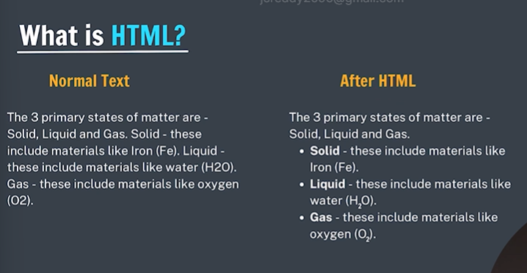
html elements:
->it is standard elements that browser recognises
Paragraph <p> </p>
Heading <h1> </h1>------<h6> </h6>
Image
->the component used to design the structure of websites are called html tags.
-><p>it is opening tag
</p>it is closing tag
<p> this is paragraph<p/>it is a paragraph tag
this is paragraphcontent

hello world in html
<p>helloworld</p>
->paragraph tag will use the next line if we use multiple paragraph tags
->bold tag <b> word</b>
nesting tags:the tags we written inside another tag
heading elements:the <h1> to <h6> html elements represent six levels of section headings <h1> is the highest section level and <h6> is the lowest.
-html boilerplate
This is the standard format or skeleton of writing html code
<DOCTYPE html>->it tells the version of html
<html>root tag
Hierarchial arrangement in html is html ->head ->title
<head> </head>in this we use for to link with the css and js and styling and also for giving extra information about the website int his meta information will be present.
<title> </title> it is for naming the website like it will not present in the web page it is int the title bar.
<body> </body> whatever we are seeing in the webpages all is written in the body tag.
indentation ->proper spacing

lists in html
Unordered list
<ul> unordered list
<li>bread</li> list item
<li>jam</li>
<li>vinayaka</li>
</ul>
ordered lists:in ths we get the order like a,b,c,d or 1,2,3, for like this
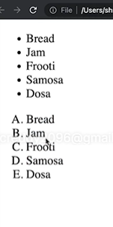
<ol>
<li>bread</li>
<li>om</li>
</ol> in this it will print as 1,2,3 normally but if we want a,b,c,d or A,B,C,D….. for this we need to write <ol type=”A”> or <ol type = “a”>

HTML Attributes:attributes are used to add more information to the tag
For ex:
<html lang=’”en”> lang is attribute and en is the value
anchor element
Used to add links to your page. By this we can move from one page to another page by clicking it .
Syntax:
<a href=”https://google.com>google</a>
Here href is the attribute and href:hyper text reference
There are two types of links we use
Absolute : directly we paste the website links from the chrome
Realtive: we use this relating one file to another file in our laptop .
image element
Used to add image to your page
<img src=”image.png” alt=”random image”>
For image tag there is only single tag
In this we can get image by getting the source link if it is not in the same folder if it is in the same folder then we just give the name of the picture
Br tag
Used to add next line (line breaks) to your page
Syntax
<br>
Bold,italic&underline tags
<b> bold </b>
<i>italic</i>
<u> underline</u>
comments in html
<!-- comments --->
Comments are ignored by the compiler it is not printed or any I just for understanding by the user.
To comment out a selected line we use this
Ctrl+forward slash(/)
html is not case sensitive
Case sensitive is there means a and A both are not same.
If there is no case sensitive then both are same.
java script is a case sensitive language and also java,c++ also same.
differnce between inline v/s block

Block elements:
Takes up the full width available
It stats from new line
Inline elements
Takes up only necessary width
Don’t start from the new line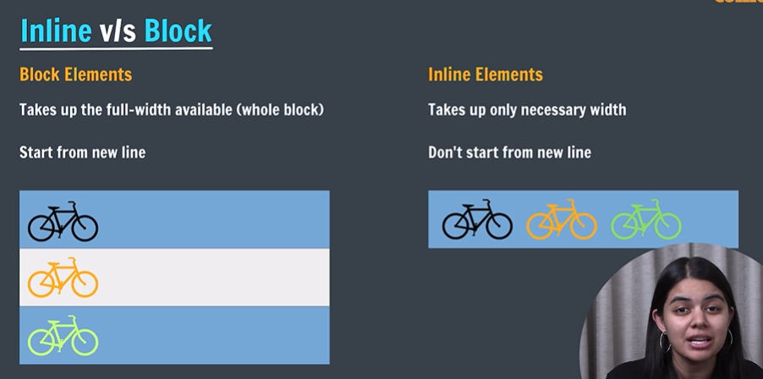

Am I inline or block
Header it is block element
->paragraph element it is block element
->anchor tag is inline element
->image element is inline element
div element
Div is a container used to hold other html elements or group elements together
It is block element
span element
->Span is also a generic container used to hold other html elements or group elements together
->it is an inline element.
hr tag
->horizontal rule element
<hr/>
->this tag will give a horizontal line
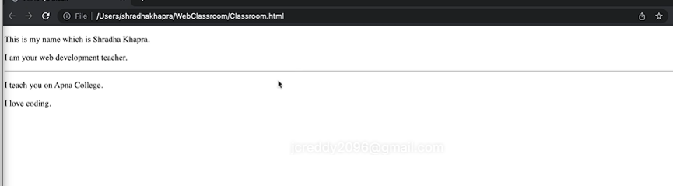

Sub&sup tag
->subscript and superscript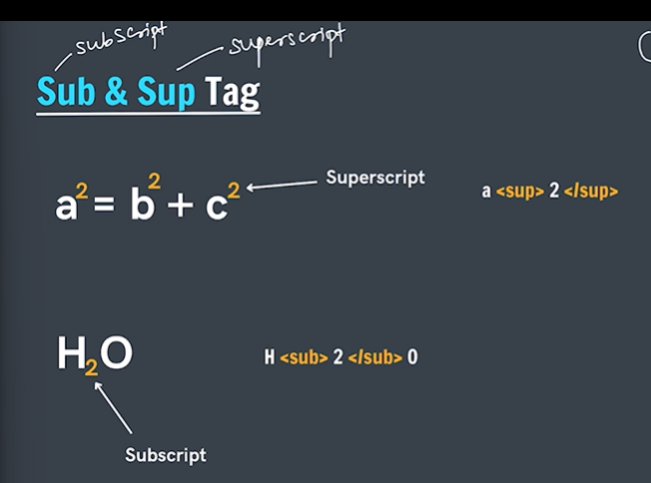
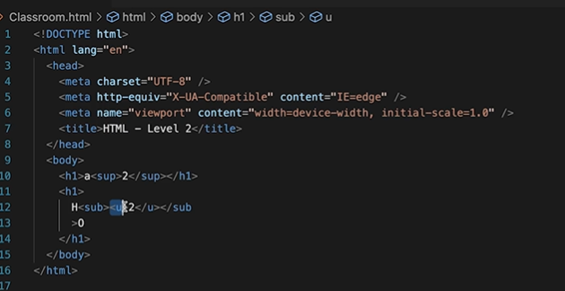

Semanatic markup
->it is the markup that relates to the meaning of content.
->semanatic means by seeing the tag we can understand what it means
ex:header,paragraph,img
->non-semanatic:by seeing the tag we cannot understand what the tag what work it will do
Ex:div,span
why we use semantics
->by seeing it will be meaninigful
->seo friendly seo:search engine optimization
->readable and user experience
Semantics markup tags under it
<header> </header>
<main> </main>
<footer> </footer>
<nav> </nav> ->it is for the navigation purpose
<article></article>
<section> </section> it works like the div tag in it related content will be there
<aside> </aside> it consists of related links/contents

html entities
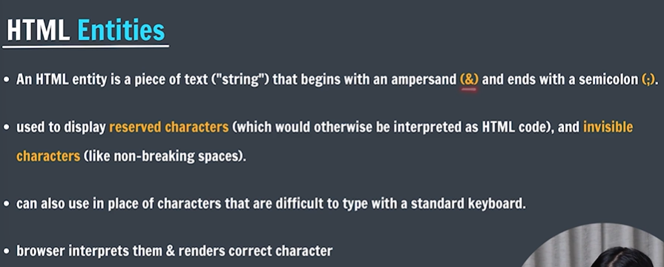
->for space we write &nbsp;
->In html < will directly not visible so we want to write it as &lt;
->for > &gt;
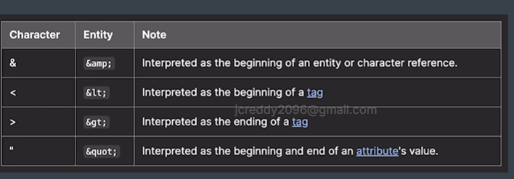

understanding html 5
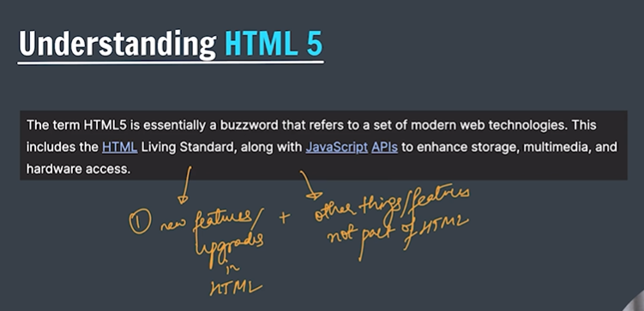
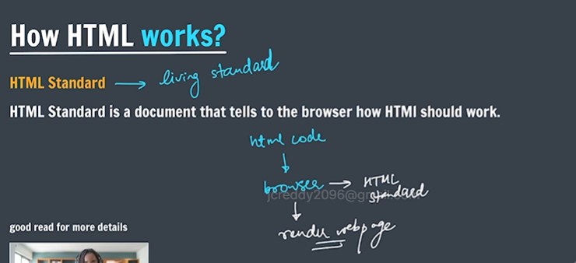
video tag:

<h2>Example of Video Tag</h2>

<!-- Video with controls -->
<video src="sample.mp4" width="400" controls></video>

tables in html
Generally in tables will consist of rows and columns
<tr> ->used to display table row. Here it will create a row a single row
<td> -> used to display table data . it is the data which we written inside the row
<th> ->used to display table header ->it is for writing the main headings in the table
semnatics in tables
<thead> to wrap the table header.
<tbody> to wrap table body
<tfoot> to wrap table footer
Colspan & rowspan attributes
Used to create cells which spans over multiple rows or columns.
forms in html
Forms are used to collect data from the user.
Syntax:
<form>
Form content
</form>
action attribute
Action attribute is used to define what action needs to be formed when a form is submitted or where the form data should be sent.
<form action=”/action.php”>

form elements
Input
- Used to create multiple form controls
- There are multiple types of inputs that can be created using type attribute.
- 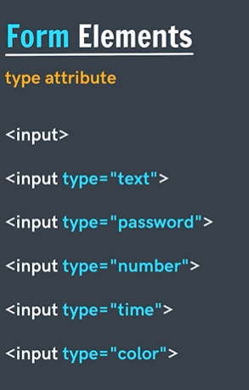

place holder

->it is a attribute
-> <input type=”text” placeholder=”enter name”>

label
- Label elements represents a caption for an item in a user interface
- <label>
Enter username:
<input type=”text” placeholder=”username”>
</label>

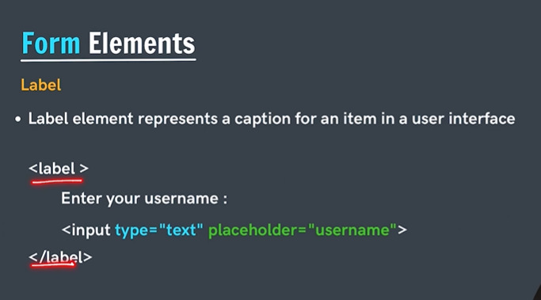
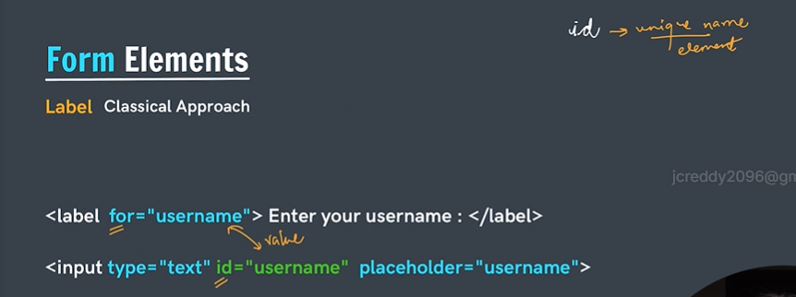

button element
<button>submit</button>
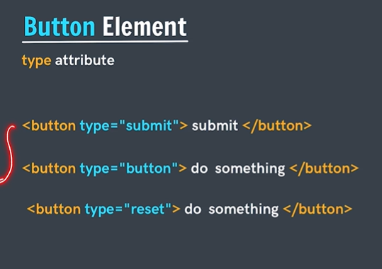
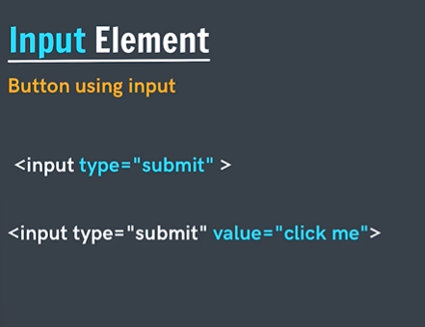
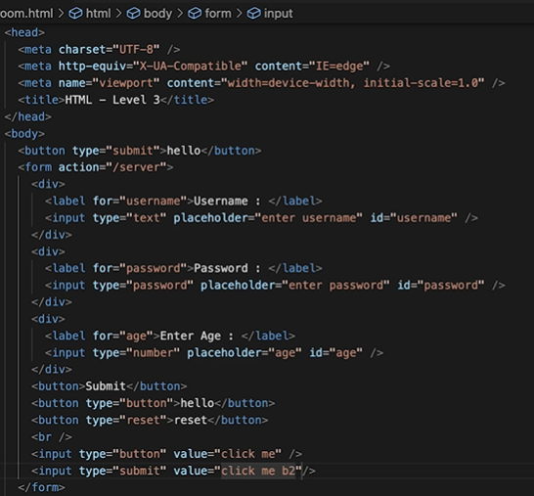
--

Name attribute:
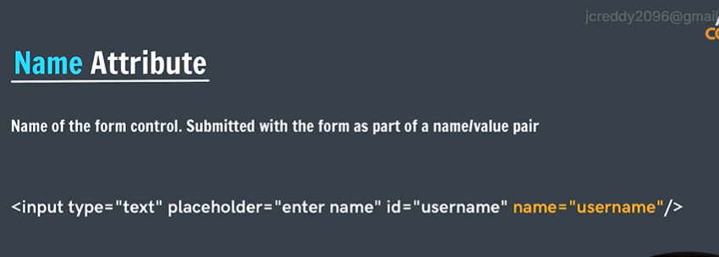
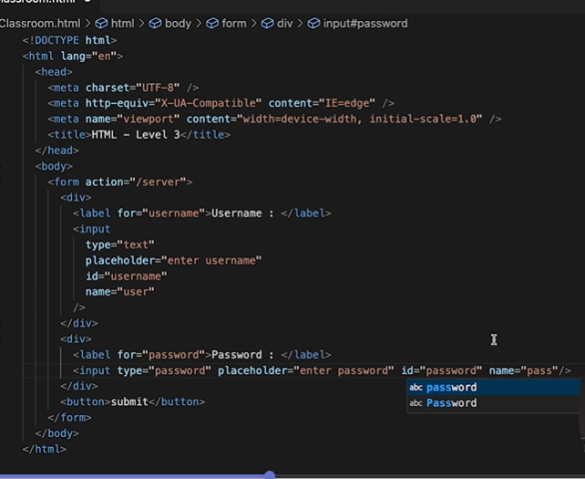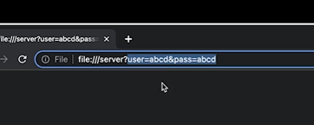

checkbox: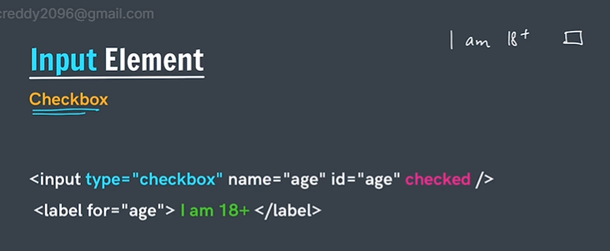
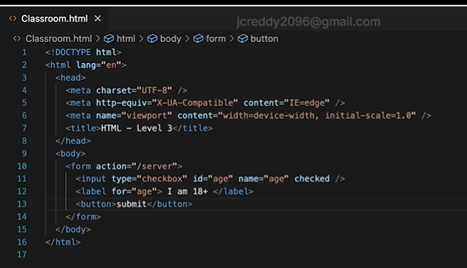
If we put tick mark in checkbox then it passes as on
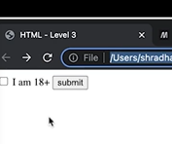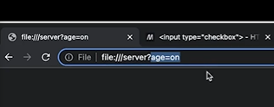

Radio Button
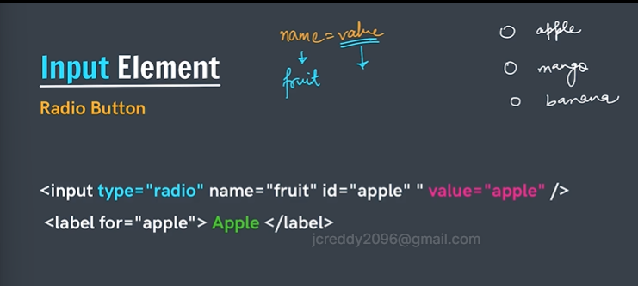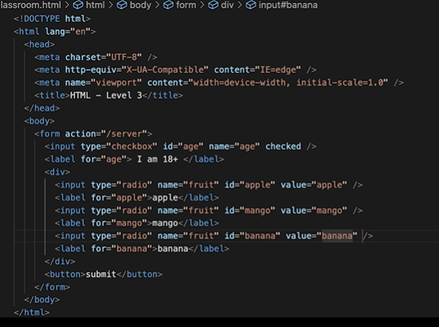
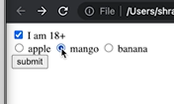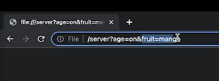
- If we didn’t mention value attribute then fruit = on will be shown if we mention value then it will be shown like this
- For the name attribute we put same for all because we want any one of them if we put unique then we will select all.
- 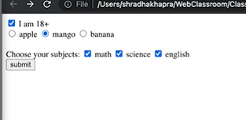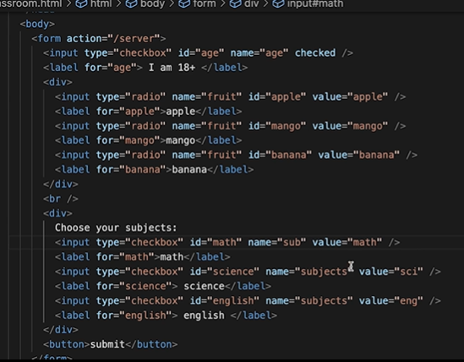
- Select element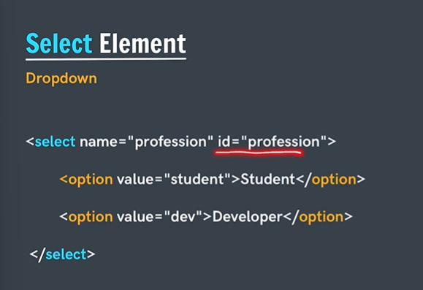
- 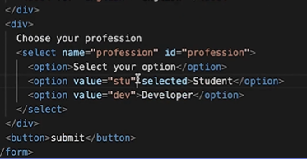
- 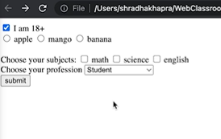

Range input element
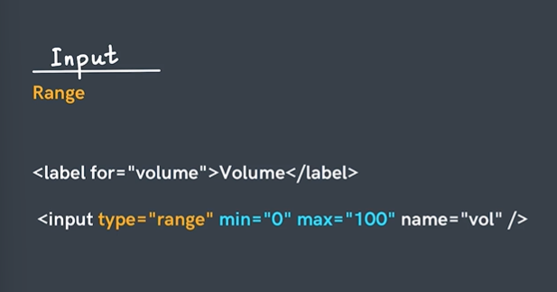
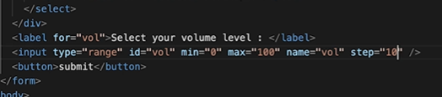
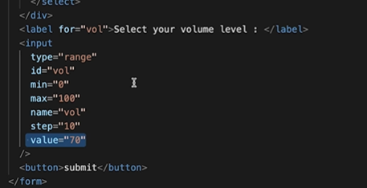
->if we put value = 70 then default after refresh the page also 70 will be there if we submit it will pass as 70 if we change then the value will change and passed.
